**SRS DOCUMENT OF**

**ATTENDANCE MANAGEMENT SYSTEM**

**DONE BY:**

**PRIYAVARSHINI.A(111723203077)**

**JAYAVARSINI.M(111723203041)**

**PRIYADARSHINI.K(111723203075)**

**KAYALVIZHI.V(111723203047)**

**IT DEPT - B FIRST YEAR**

**ATTENDANCE MANAGEMENT SYSTEM**

**OBJECTIVE:**

The main objective of attendance management system

Is to reduce errors and save time.

**USERS OF THE SYSTEM:**

* School management or college management

**FUNCTION REQUIRMENTS**:

1. These reports should be completely customizable, allowing you to filter by employee or student, date period, and other criteria.
2. It should also contain roles and permissions that regulate who has access to, modifies, or deletes attendance data.
3. Managers or administrators should be allowed to approve or reject leave requests as well.
4. Scheduling: The system should allow managers or administrators to plan shifts or courses, as well as alert employees or students of their future schedules.
5. Time and attendance reporting: The system should generate attendance data such as attendance records, attendance percentages, and tardiness statistics.
6. Mobile access: The system should be accessible through mobile devices such as smartphones or tablets, enabling employees or students to remotely check their attendance or request time off.
7. Data backup and recovery: A solid data backup and recovery solution should be included in the system to ensure that attendance data is not lost in the event of a system failure.
8. Attendance tracking: The system should be able to track attendance for both individual employees or students as well as groups or courses.
9. This might involve writing down the dates and hours of arrival and departure, as well as the duration of stay.
10. Payroll integration: The system should be able to connect to payroll systems in order to calculate and monitor employee or student pay based on attendance data automatically.
11. Access control: The system should include a secure login mechanism to ensure that only authorised users may access attendance data.
12. Employees or students should be able to use the system to request and track leave, such as vacation or sick time.

**Attendance management system non-functional requirements:**

They describe the over

1. Usability: The system should be simple to use and understand, with a basic interface.
2. Maintainability: The system should be easy to maintain and update, enabling you to add new features or fix problems without disturbing the system.
3. Accessibility: The system should be accessible to all employees, regardless of physical location or device.
4. Performance: The system should be able to process a large number of employees’ attendance data in a timely and error-free way.
5. Scalability refers to the system’s capacity to accept an increasing number of employees or attendance records without deteriorating performance.
6. Compatibility: The system should be compatible with other systems or tools used by the company, such as payroll or human resources.
7. Reliability: The system should be reliable and capable of working without defects or malfunctions even when exposed to heavy usage or unexpected circumstances.
8. Security: The system should be protected against unauthorised access and modification of attendance data.
9. Integration entails the system’s ability to interact with other systems or tools, such as time management or scheduling software.

**STANDARD FEATURES:**

1.Web based software allowing anytime anywhere access

2.Implement fast and comprehensive timesheet easily and quickly

3.Late comings, early goings are automated by defined policies

4.Keep a track of leaves, absence

5. Completely secured and scalable solution

6.Customization features to meet specific requirements

7.Retrieval of historical data is quick

**USE CASE DIAGRAM:**

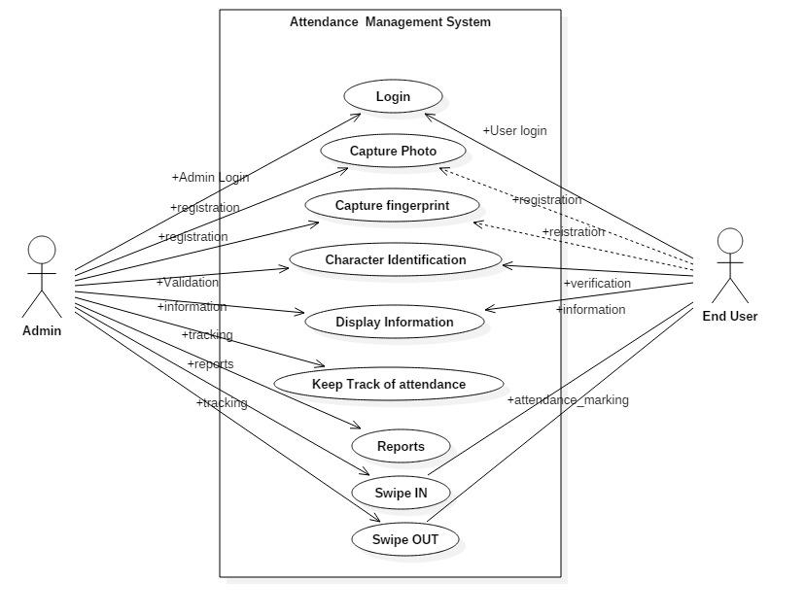

**SEQUENCE DIAGRAM:**

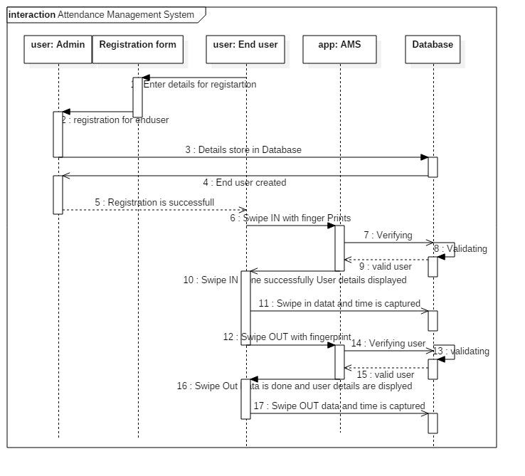

**OPERATING ENVIRONMENT:**

This project will go through two steps:

The first step is to have the automatic attendance device in every classroom in the school. These devices will be connected to the computer and its system. Students have to put their fingerprints on file in the registration office on their first day to save their fingerprint data in the database.

The second step is to connect this system to the Canvas site. That is to connect the Canvas database to the system database to work as one system on the Canvas site. This step would complete the work, and the project will work in one system. That is because the attendance report will be updated all the time. Also, the Canvas site will control all the students’ attendance reports not in a separate system or database.

This system has some requirements to be accomplished. It needs hardware and software.

Hardware requirements:

1) Biometric Fingerprint Scanners

2) Cables for the device

The current system work is already in existence. However, we need some system requirements:

1) Create new databases and indexes for students and class list by using MySQL.

2) Make connation to the current database

3) Design interfaces for the users

4) Design an attendance page on Canvas

5) Programming using JavaScript, PHP, and HTML

**EXTERNAL INTERFACE REQUIREMENTS**

**USER INTERFACES:**

**Login Display:**

This is the main login in the system which appears in the Biometric Fingerprint Scanners. This interface designed to be in the device view in every class. “Scan Your Thumb” is the login to the class and the system.

**Welcome View page:**

This view will be also in the device screen. This page means the device accepts the fingerprint data and identify the person. So, in the screen, it will show the student information (name, and his picture). Also, it has the data for the particular class at the time.

**Error message view:**

If the student data is not identified with the device, the student has to check with the registration office to fix that. This means, this student does not have a record in the system. Or, the student is in the wrong class or wrong class time.

**Add a new student:**

This page appears in the registration office when they add a new student. Students have to scan their fingerprint in the device. And then, their fingerprint record will be added by the employer to make sure the student has his record with his information; not anyone else’s. The employer submits the information to the system and the system will give a message that this student with his fingerprint information has added to the system.

**Student Report:**

This page will appear in a separate page in the system. It is a web page gives the students current report during the semester. It has the weekly report, the check in each class, and grade. It gives the student how many times he has been in the class and how many he missed. Also, it provides all grades that student makes during the semester.

**Faculty Attendance Report:**

This is a web page which has all student’s reports in the class. This page is controlled by a faculty member. Faculty can modify in this report. This page has the name, the time of the class and the class room number. It has weekly reports with the average of the student’s attendance in every class time. Also, it calculates the total grade for every student.

**Missed class form:**

If a student missed any class, the system automatically will send to him this form. Students should write their note and submit it to the system. The system will send it to the faculty member to have the final decision.

**HARDWARE INTERFACES:**

The hardware environment in this system will use the Biometric Fingerprint Scanners. These scanners will play a role in the system. This device must be available in every classroom in the school. Also, it must be in the registration office. The interfaces for the hardware part are the same in the registration office’s interface. This part of the interface has also other components, such as student’s information, faculty information, class’s information, and other related information. All of these data are stored in the database and end with the device screen and web pages.

**SOFTWARE INTERFACES:**

The system will use:

1) Biometric Fingerprint Devices display software

2) Web pages for the forms HTML, PHP

3) Server

4) Programming using JavaScript

5) Database uses with MySQL.

**Other Nonfunctional Requirements**

**Security Requirements:**

**The Current System security:**

The current system, which is Canvas, has its policy on its site page. The current system builds upon a user name and password access. Students and faculty can access to his/her account through their page, and they can control it.

The system now has its own policy and security; however, the new feature we will add to the system will need some security requirements to the system. The new feature in the system will add some values to the current policy to maintain the security in the right way. It also provides proof of compliance.

The new policy in the system will deal with the security in many cases. The plan is to secure the outsider and insider community of misused the system (e.g., identification theft). Strong security is part of the policy’s purpose.

**User Access:**

Inside the community, there are students, faculty, and office staff registration who are going to use the system. The main users of   the entity are students. They use it every day by scanning their fingerprints at the beginning of each class. Faculty will only use the system through Canvas, and they can access the student’s information. The faculty member will use the entity to control the attendance page. Faculty’s job is to add, edit, update and delete any record. Furthermore, registration office staff will check on every student’s identification for security purposes. They check on students for identification in person before they add, edit, update and delete any information from their fingerprint records in the system. The staff will ask students for ID for identification and print their thumb in the device if needed to make sure the person is identified.

**Threats to the system security:**

This system may face many threats. Sometimes, it comes from a community insider. This could be someone who discloses the data form the database where it located, in the registration office. Another type of deception is false identification, such as a fake ID, when students present in the registration office. The system will reduce this kind of misuse because the fingerprint identification is more secure than others. However, staff in the registration office should check on the identification carefully before initiating any processes in the system. These records will be the official record for all students, since they begin school and until they graduate.

**Levels of security:**

1) **Hardware**: The fingerprint devices must be located in a secure location in every class. It should be behind the entrance that everyone can see the device inside and outside the class.

2) **The operating system**: the security in this case will be in the same level of the Canvas security.

3) **The network**: it is part of the current system security.

4) **The data management system**:

1. Students can access to their classes to the system check by fingerprint.

2. Faculty access to Canvas would be the same as we have now, and they will control the attendance page/report.

**Level of access**

**Subject:**

**People level:**

1) Users (students).

2) Faculty (Control on Canvas).

3) Registration office (control the system).

**Computer level:**

1) Hardware (fingerprint reader)

2) Software (the system)

**Access request (operation)**

The operation will be presented in the security matrix that provides every task in the system and everybody in all task responses.

**Reference Monitor**

The authorization and the access control present in the security matrix below: Faculty can create, read, update and delete the “Report student,” “Report faculty,” and only read “process student check.”

Registration office can create, read, update and delete the “add a new record,” “Process student’s check,” and they can only read the “Check-in.”

Student are able to create and read the “Check-in,” and they can only read the “Receive student check” and “report student”.

**System Architecture:**

A system architecture is the ideational model that defines the structure, behaviour, technology and other views of any system. In the fingerprint system, we have the whole structure to build the system. In this architecture, we will describe the formal definition and the representation of the system. This description is a high level that can show the relationship between the components induces software, hardware and the communication between them.

The first level of this architecture is the hardware component. The hardware here is the fingerprint reader which will be connected to the system and other components. Then, it will check with security level. The security level here has database for the security purposes. Next, the architecture level will go to the process task, which has four components in the software. They are chick in for every class when student scan his/her fingerprint, check on fingerprint, this is kind of the security and to check into every class. Then check into the class, which is the class chick list to make sure the student in the right class. Finally, notify step, this step is to report everyone involves in the system to receive a notification.

The last two level of this architecture are the access data and the databases. There are three databases for this step which are for the classes, students, and fingerprint records. This architecture is the whole structure for the Automatic Attendance System. So, all process here will complete the communication between all the components.

**Appendix A: Use Case model:**

Develop a system that can help the Dominican university community to take the attendance automatically that will be connected with Canvas page on a new attendance page

The target actors are:

1. Students

2. Faculty

3. Registration Office

All the data will be gathered by the Biometric Fingerprint Scanners and Readers that will help faculty, students and, registration to reach the end user by the Canvas page.

We will create the separate page on Canvas to take the attendance. Fortunately, we do not need to create the login page, as we already have the Canvas site to log into the system, starting with the students, faculty, and the registration office staff.

1. Students:

a. For the first time, students go to the registration for the fingerprint scanning.

b. In the beginning of each class, students must scan their thumbs in the Biometric Fingerprint Scanner.

c. Each student, receive the automatic attendance grad on his Canvas page.

d. Students will receive the notification on his/her Canvas page for the attendance.

e. Students can access to his page and look/print at his current attendance report and the final report.

f. Student would receive a warning message if they miss more than two classes.

2. Faculty:

a. To know who is in attendance automatically.

b. On the class time, faculty will receive a report for this particular time.

c. Faculty could know who is in attendance or missing that class.

d. On the Canvas page, they have every student’s report and grades.

e. They have the percentage of the attendance for the whole semester.

f. They can print the final attendance report for the class by the end of the semester.

3. Registration:

a. Registration office has all the students’ fingerprint records.

b. They check the identification for every student.

c. The fingerprint code will give access to the student account on Canvas (no username/password needed at this time).

d. They use these records for any student who will come by the office as the identifier.

e. They connect this information with the classes.

f. Students would have a hold if he/she does not have a fingerprint record in the registration office.

**References:**

<https://www.tutorialspoint.com/software_engineering/software_project_management.htm>

<http://www.ignousolvedassignments.com>

<http://feedburner.google.com/fb/a/mailverify?uri=ignousolvedassignments_com>